**Wrapping the Solenoid**

1. Secure a strand of magnet wire to the solenoid tube.
2. Wrap several turns of magnet wire around the solenoid tube.
3. Leave a long tail of wire and tuck this wire into the open end of the body.
4. Secure the wire you wrapped with a piece of tape.

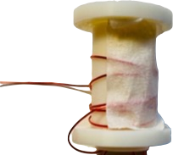

1. Wrap magnet wire around the solenoid tube.
2. Use a rubber band winder to wrap wire around the solenoid body. It will take about 300-400 wraps to cover the solenoid body.
3. After the solenoid is completely wrapped, secure the wire with a piece of tape and cut off the end, leaving a long tail.

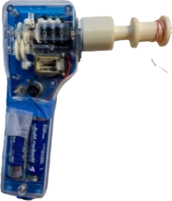 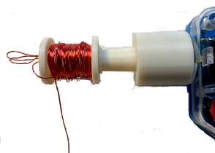 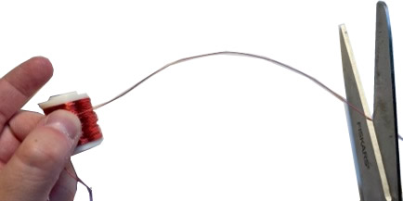

1. Use sandpaper to remove the red insulation from the two ends of the wire.

